Meter Stick
# Source: AI Source: Provided by: [Data Path: Persons Table -> ID Column: 1, Name_En Column: Motasem Essam] -> From: [ChatGPT] on [7/17/2026]
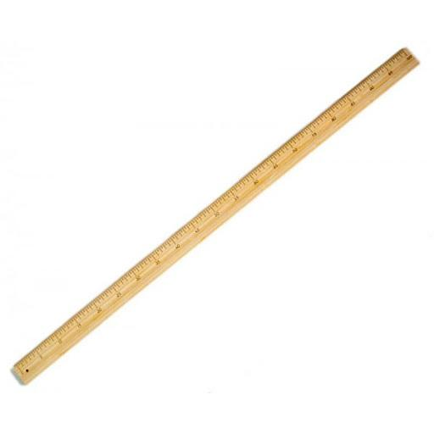
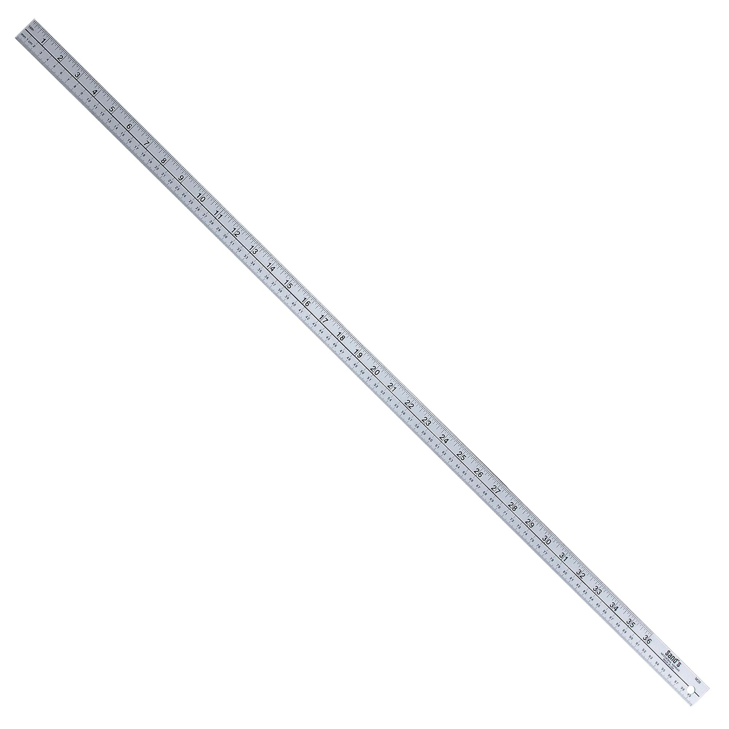
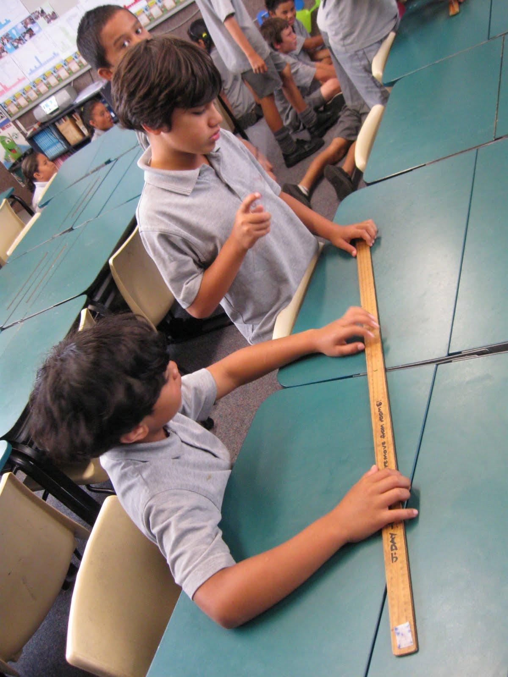
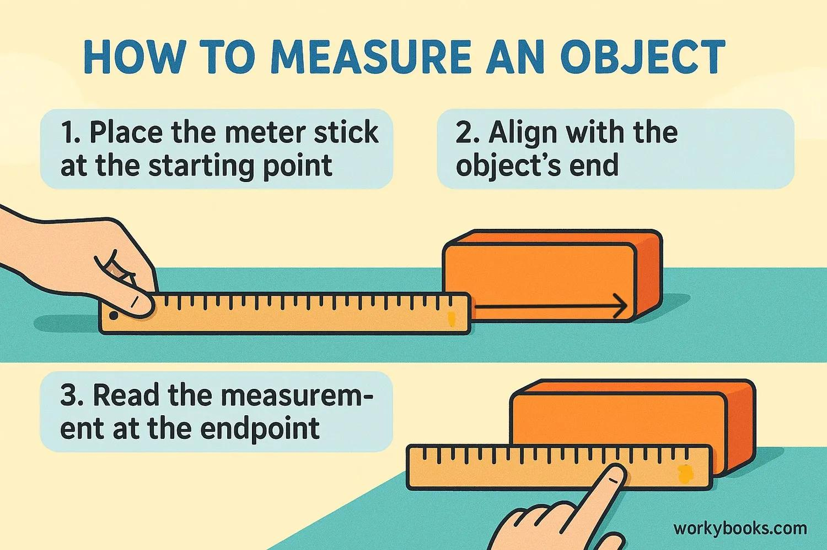
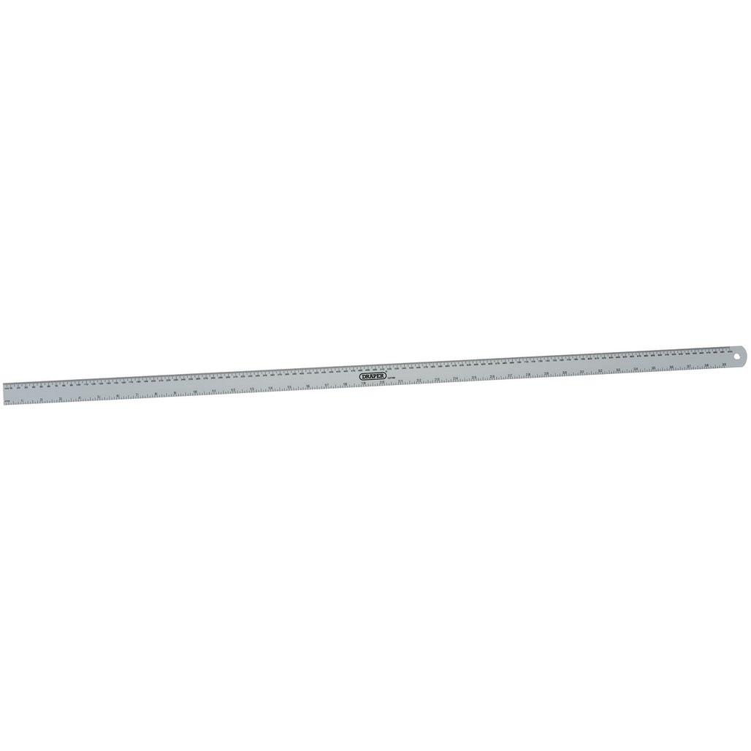
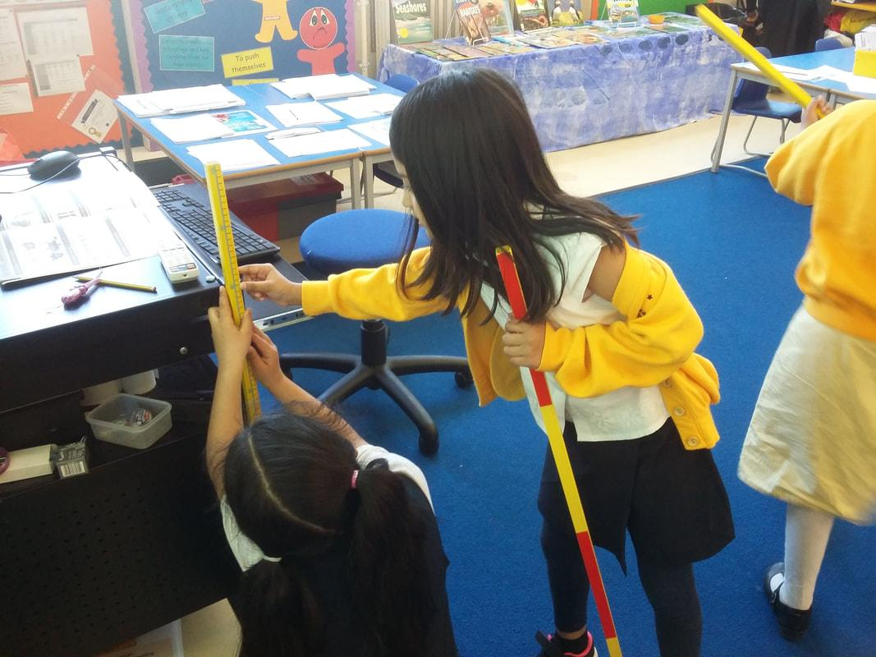
A Meter Stick (also called a Meter Rule) is a rigid measuring instrument exactly 1 meter (100 centimeters or 1000 millimeters) in length. It is used to measure longer linear dimensions than a standard ruler while maintaining good accuracy.
Meter sticks are commonly used in schools, laboratories, engineering, construction, woodworking, manufacturing, and scientific experiments.

Definition
# Source: AI Source: Provided by: [Data Path: Persons Table -> ID Column: 1, Name_En Column: Motasem Essam] -> From: [ChatGPT] on [7/17/2026]
A Meter Stick is a rigid measuring instrument one meter long, marked with graduated metric units, used to measure linear dimensions and draw long straight lines.

Purpose
# Source: AI Source: Provided by: [Data Path: Persons Table -> ID Column: 1, Name_En Column: Motasem Essam] -> From: [ChatGPT] on [7/17/2026]
A Meter Stick is used to:
- Measure long lengths.
- Measure width and height.
- Measure furniture dimensions.
- Measure laboratory specimens.
- Draw long straight lines.
- Perform educational experiments.
- Assist in construction and woodworking.

Construction
# Source: AI Source: Provided by: [Data Path: Persons Table -> ID Column: 1, Name_En Column: Motasem Essam] -> From: [ChatGPT] on [7/17/2026]
A typical meter stick consists of:
- Straight rigid body
- Metric graduation markings
- Zero reference mark
- Measuring edge
- End reference

Common Materials
# Source: AI Source: Provided by: [Data Path: Persons Table -> ID Column: 1, Name_En Column: Motasem Essam] -> From: [ChatGPT] on [7/17/2026]
Meter sticks are commonly made from:
- Wood
- Aluminum
- Stainless steel
- Plastic
- Fiberglass

Measurement Units
# Source: AI Source: Provided by: [Data Path: Persons Table -> ID Column: 1, Name_En Column: Motasem Essam] -> From: [ChatGPT] on [7/17/2026]
A meter stick typically displays the Metric System.
Common graduations include:
- Millimeters (mm)
- Centimeters (cm)
- Meters (m)
Relationships:
- 1 meter = 100 centimeters
- 1 centimeter = 10 millimeters
- 1 meter = 1000 millimeters
Some meter sticks also include an Imperial Scale (inches and feet), though metric-only models are more common.

Measuring Range
# Source: AI Source: Provided by: [Data Path: Persons Table -> ID Column: 1, Name_En Column: Motasem Essam] -> From: [ChatGPT] on [7/17/2026]
Instrument | Measuring Range
Meter Stick | 0–1 m (0–100 cm)

Least Count (Resolution)
# Source: AI Source: Provided by: [Data Path: Persons Table -> ID Column: 1, Name_En Column: Motasem Essam] -> From: [ChatGPT] on [7/17/2026]
The least count is the smallest marked division.
Typical values:
Type | Least Count
Standard Meter Stick | 1 mm (0.1 cm)

How to Measure with a Meter Stick
# Source: AI Source: Provided by: [Data Path: Persons Table -> ID Column: 1, Name_En Column: Motasem Essam] -> From: [ChatGPT] on [7/17/2026]
- Place the meter stick parallel to the object.
- Align the zero mark with one end of the object.
- Ensure the stick lies flat against the object.
- Read the graduation at the opposite end.
- Record the measurement using the correct unit.

Example
# Source: AI Source: Provided by: [Data Path: Persons Table -> ID Column: 1, Name_En Column: Motasem Essam] -> From: [ChatGPT] on [7/17/2026]
Suppose the object ends at the 82.4 cm mark.
The measured length is:
- 82.4 cm
- 824 mm
- 0.824 m

Accuracy
# Source: AI Source: Provided by: [Data Path: Persons Table -> ID Column: 1, Name_En Column: Motasem Essam] -> From: [ChatGPT] on [7/17/2026]
A standard meter stick typically provides measurements accurate to approximately ±0.5 mm, depending on:
- Manufacturing quality
- User technique
- Reading angle
- Condition of the stick

Sources of Error
# Source: AI Source: Provided by: [Data Path: Persons Table -> ID Column: 1, Name_En Column: Motasem Essam] -> From: [ChatGPT] on [7/17/2026]
Instrument Errors
- Worn edges
- Damaged graduations
- Warped stick
- Manufacturing defects

Observation Errors
- Parallax error
- Reading the wrong graduation
- Incorrect estimation

Positioning Errors
- Misaligned zero mark
- Measuring from the physical edge instead of the zero mark (if they differ)
- Stick not parallel to the object

Environmental Errors
- Expansion due to temperature (especially metal meter sticks)
- Dirt between the object and the measuring edge
- Moisture affecting wooden meter sticks

Applications
# Source: AI Source: Provided by: [Data Path: Persons Table -> ID Column: 1, Name_En Column: Motasem Essam] -> From: [ChatGPT] on [7/17/2026]
Meter sticks are widely used in:
- Schools
- Physics laboratories
- Engineering
- Architecture
- Construction
- Carpentry
- Manufacturing
- Interior design
- Scientific experiments

Advantages
# Source: AI Source: Provided by: [Data Path: Persons Table -> ID Column: 1, Name_En Column: Motasem Essam] -> From: [ChatGPT] on [7/17/2026]
A Meter Stick:
- Measures longer distances than a ruler.
- Is rigid and stable.
- Provides good accuracy.
- Requires no power source.
- Is inexpensive and durable.
- Can also serve as a straightedge.

Limitations
# Source: AI Source: Provided by: [Data Path: Persons Table -> ID Column: 1, Name_En Column: Motasem Essam] -> From: [ChatGPT] on [7/17/2026]
A Meter Stick:
- Is less portable than a retractable measuring tape.
- Cannot easily measure curved surfaces.
- Is less precise than Vernier calipers or micrometers.
- Is limited to measurements of up to one meter without repositioning.

Comparison with Other Length Measuring Instruments
# Source: AI Source: Provided by: [Data Path: Persons Table -> ID Column: 1, Name_En Column: Motasem Essam] -> From: [ChatGPT] on [7/17/2026]
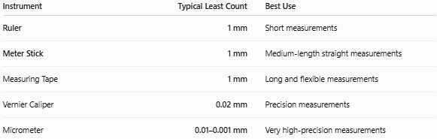
Instrument | Typical Least Count | Best Use
Ruler | 1 mm | Short measurements
Meter Stick | 1 mm | Medium-length straight measurements
Measuring Tape | 1 mm | Long and flexible measurements
Vernier Caliper | 0.02 mm | Precision measurements
Micrometer | 0.01–0.001 mm | Very high-precision measurements

Care and Maintenance
# Source: AI Source: Provided by: [Data Path: Persons Table -> ID Column: 1, Name_En Column: Motasem Essam] -> From: [ChatGPT] on [7/17/2026]
To maintain accuracy:
- Keep the measuring edge clean.
- Store the stick flat.
- Avoid bending or warping.
- Protect the graduations from wear.
- Replace damaged or warped meter sticks.

Common Mistakes
# Source: AI Source: Provided by: [Data Path: Persons Table -> ID Column: 1, Name_En Column: Motasem Essam] -> From: [ChatGPT] on [7/17/2026]
- Starting from the damaged edge instead of the zero mark.
- Reading from an angle, causing parallax error.
- Using a warped stick for precision work.
- Measuring uneven or curved surfaces without proper alignment.

Key Points
# Source: AI Source: Provided by: [Data Path: Persons Table -> ID Column: 1, Name_En Column: Motasem Essam] -> From: [ChatGPT] on [7/17/2026]
- A Meter Stick is a 1-meter-long rigid measuring instrument.
- It is graduated in millimeters, centimeters, and meters.
- Typical least count is 1 mm.
- It is ideal for medium-length straight measurements.
- It is commonly used in education, laboratories, engineering, construction, and woodworking.

Conclusion
# Source: AI Source: Provided by: [Data Path: Persons Table -> ID Column: 1, Name_En Column: Motasem Essam] -> From: [ChatGPT] on [7/17/2026]
A Meter Stick is a simple yet reliable measuring instrument designed for measuring linear dimensions up to one meter. With a standard 1 mm resolution, it offers greater reach than a standard ruler while maintaining ease of use and good accuracy. Its rigid construction makes it well suited for measuring straight objects and performing laboratory experiments, educational activities, and engineering tasks. Although it cannot match the precision of instruments such as Vernier calipers or micrometers, the meter stick remains an essential tool for everyday length measurement in scientific, technical, and educational environments.

